MAT „opakovanie učiva“ 1.A

Vyfarbi, obtiahni, nakresli geometrické tvary

|  |  |  |
| --- | --- | --- |
|  |  |  |
|  |  |  |
|  |  |  |
|  |  |  |

**MAT „opakovanie učiva“ 1.A**

**Počítaj s bocianom**

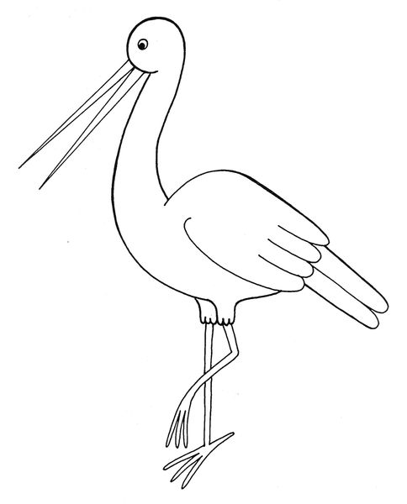

|  |  |  |  |  |
| --- | --- | --- | --- | --- |
| 5 | **_** | 3 | **=** |  |
| **_** |  | **_** |  | **_** |
| 2 | **_** | 2 | **=** |  |
| **=** |  | **=** |  | **=** |
|  | **_** |  | **=** |  |

Vypočítaj príklady v tabuľke. Bociana si vyfarbi.

MAT 1.A

GEOMETRICKÉ TVARY – sčítanie a odčítanie

|  |
| --- |
| + = |
| - = |
| + = |
| - = |
| + = |
| + = |
| - = |

SJL 1.A

.



SJL „obtiahni a vymaľuj“ - opakovanie 1.A

L 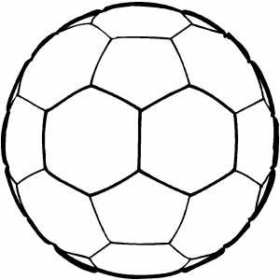

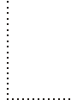    

V 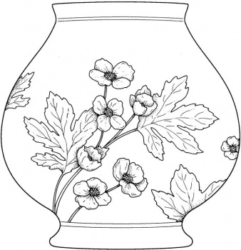

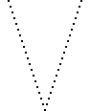    

SJL 1.A

Nakresli čiary doprostred cestičiek, neodďaľuj ceruzku od papiera

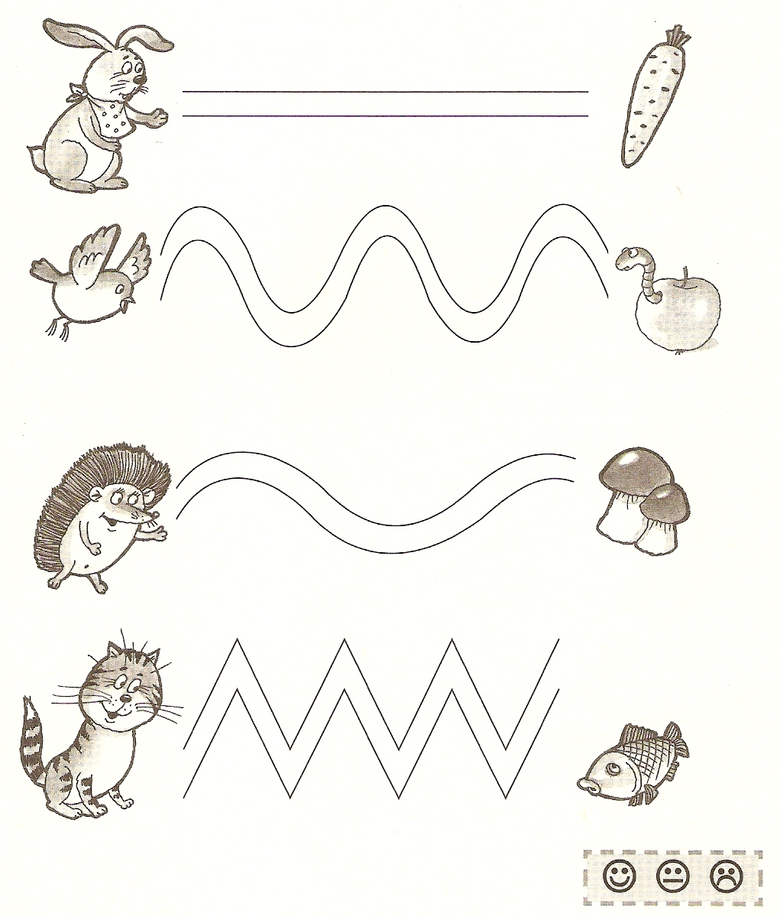 a nepreťahuj okraje cestičiek. Obrázky vamaľuj.

MAT 4.A

Zopakuj si:

1. Počítaj do 100, doplň chýbajúce čísla.

**61**

**62**

**63**

**64**

**66**

**68**

**71**

**74**

**75**

**77**

**78**

**79**

**81**

**82**

**85**

**87**

**89**

**90**

**31**

**32**

**35**

**37**

**42**

**43**

**44**

**45**

**48**

**49**

**50**

**51**

**52**

**53**

**58**

**59**

**1**

**2**

**3**

**5**

**6**

**7**

**9**

**10**

**11**

**12**

**14**

**18**

**20**

**21**

**23**

**24**

**26**

**29**

**30**

1. Porovnaj:

74

48

57

57

89

98

26

29

93

39

73

29

MAT 4.A

1. Doplň čísla do číselného radu:

|  |  |  |  |  |  |  |  |  |  |
| --- | --- | --- | --- | --- | --- | --- | --- | --- | --- |
| **11** |  | **13** |  |  | **16** |  | **18** |  |  |

|  |  |  |  |  |  |  |  |  |  |
| --- | --- | --- | --- | --- | --- | --- | --- | --- | --- |
|  |  | **45** | **46** |  |  | **49** |  | **51** |  |

|  |  |  |  |  |  |  |  |  |  |
| --- | --- | --- | --- | --- | --- | --- | --- | --- | --- |
|  | **61** |  | **63** | **64** |  |  |  | **68** |  |

|  |  |  |  |  |  |  |  |  |  |
| --- | --- | --- | --- | --- | --- | --- | --- | --- | --- |
| **78** |  |  | **81** | **82** |  |  | **85** |  |  |

|  |  |  |  |  |  |  |  |  |  |
| --- | --- | --- | --- | --- | --- | --- | --- | --- | --- |
| **89** |  | **91** |  | **93** | **94** |  |  |  | **98** |

2. Doplň:

|  |  |  |  |  |  |  |  |  |  |  |
| --- | --- | --- | --- | --- | --- | --- | --- | --- | --- | --- |
| **89** |  | **91** |  | **59** |  | **61** |  | **78** | **79** |  |
|  |  |  |  |  |  |  |  |  |  |  |
| **45** |  | **47** |  | **54** |  | **56** |  | **32** |  | **34** |
|  |  |  |  |  |  |  |  |  |  |  |
|  | **16** |  |  |  | **27** |  |  |  | **30** |  |
|  |  |  |  |  |  |  |  |  |  |  |
| **58** |  | **60** |  | **89** | **90** |  |  |  | **23** |  |
|  |  |  |  |  |  |  |  |  |  |  |
| **98** |  |  |  | **43** |  | **45** |  | **19** |  | **21** |
|  |  |  |  |  |  |  |  |  |  |  |

3. Porovnaj <, > a = :

|  |  |  |  |  |  |  |  |  |  |  |
| --- | --- | --- | --- | --- | --- | --- | --- | --- | --- | --- |
| **80** |  | **90** |  | **50** |  | **60** |  | **70** |  | **90** |
|  |  |  |  |  |  |  |  |  |  |  |
| **40** |  | **40** |  | **50** |  | **80** |  | **30** |  | **60** |
|  |  |  |  |  |  |  |  |  |  |  |
| **10** |  | **80** |  | **20** |  | **50** |  | **30** |  | **40** |
|  |  |  |  |  |  |  |  |  |  |  |
| **98** |  | **78** |  | **43** |  | **45** |  | **19** |  | **21** |

SJL 4.A

Napíš celé slovo:

Napíš vetu:

Doplň: mu__

Napíš celé slovo:

Napíš vetu:

Doplň: kalu__

Napíš celé slovo:

Napíš vetu:

Doplň: droz__

Napíš celé slovo:

Napíš vetu: vetu:

Doplň: kru__

Napíš celé slovo:

Napíš vetu:

Doplň: sli__ky

Napíš celé slovo:

Napíš vetu:

Doplň: akto__ka

Napíš celé slovo:

Napíš vetu:

Doplň: trú__ka

Napíš celé slovo:

Napíš vetu:

Doplň: o__ca

Napíš celé slovo:

Napíš vetu: vetu:

Doplň: plá__

Napíš celé slovo:

Napíš vetu:

Doplň: mozo__

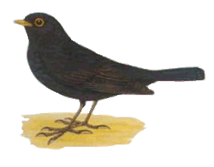

MAT, SJL 4.A

„Na druhé krídlo dokresli taký istý počet bodiek“. Včielky vymaľuj.

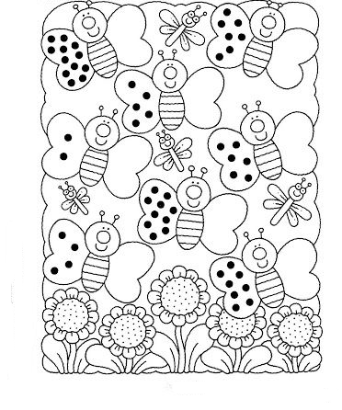

SJL 4.A

1. Cestuj lietadlom po svete. V ktorých krajinách si pristál – krajiny napíš

http://www.beruska8.cz/auta/letadla2/164.gif K O

R

A Ú

S K

____________________________

2.

http://www.beruska8.cz/auta/letadla2/164.gif N

C K

E

M E O

____________________________