[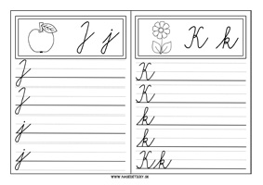](https://www.google.sk/url?sa=i&url=https://nasedeticky.sk/do-skoly/pre-prvakov/1072/ucime-sa-pisat-pisane-a-tlacene-pismenka/&psig=AOvVaw2SRI3SREGwC7nbcnWBfQXd&ust=1585935590754000&source=images&cd=vfe&ved=0CAIQjRxqFwoTCIDG0tKkyugCFQAAAAAdAAAAABAa)