Summer Style Christmas - Christmas in Australia

written by Veronika Onder

Well, the first thing is that Christmas can be VERY hot in Australia and it is a real challenge if you are used to seeing snow and having a winter Christmas. Another thing is that most Australians celebrate Christmas on 25 December by having a Christmas gathering at lunchtime that includes: cooked leg of ham, prawns, salmon, fish, lots of salads and often a barbecue (steak, sausages and burgers). This is quite different to a European Christmas where we traditionally gather on Christmas Eve (24 December) for a meal and presents at midnight. In cold climates (like in Slovakia) we also enjoy warm eggnog, hot spiced red wine and a real Christmas tree, which would die here within a few days.

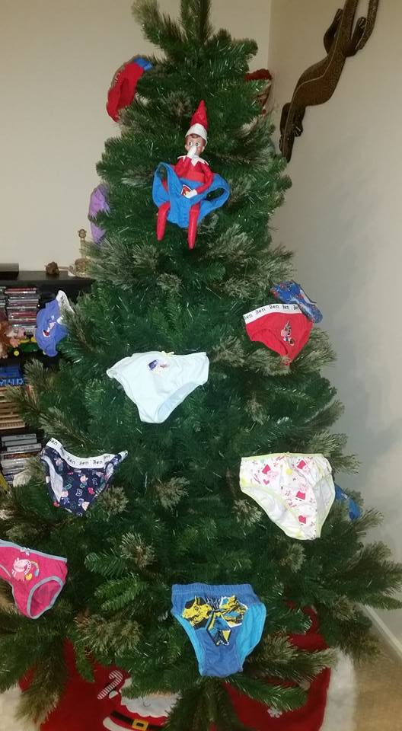
Australians have adopted many traditions from America and celebrate many holidays similarly to Americans (for example Easter with Easter bunny and Halloween).

Some people, including our household, have also adopted the tradition of an Elf on the Shelf, a little mischievous magical elf who does funny things overnight and watches over the children to make sure they behave well at Christmas.

Australians are also big fans of ‘Secret Santa’. For the Boxing Day celebration with friends everyone coming to the party is given the name of one other person attending. The job is then to buy a present (with a small limit $10-$20) for the chosen person. Each person has to bring along the present, wrapped up with the person’s name on it – the opening of presents can sometimes be very funny as Aussies like to get trick presents/or funny gifts, while others buy chocolates, wine, or other small thoughtful gift.

Some people will celebrate Christmas in July as it is winter here, with a proper Christmas tree, presents and so on.

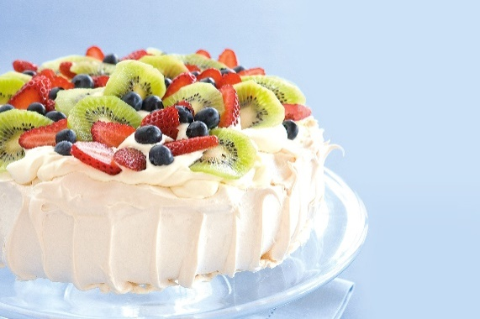
A favourite Christmas dessert here is Australian Pavlova – a lovely crisp meringue base, topped with fresh whipped creamand wonderful summer fruit – strawberries, banana, kiwi fruit, mango, raspberries, blueberries and passionfruit (and any other fruit you like).

Australians are not much into cooking or baking, so there is a large variety of food to buy from the shops.

There are some great advantages to an Australian Christmas – the Christmas day gatherings around the barbeque or at the river or beach involve lots of simple foods: barbequed meat, fresh seafood (prawns, salmon and fish), salads, chilled white wine and beer. The day is usually filled with playing outdoor cricket, kite flying, a rugby game,volleyball, swimming in the ocean, pool or river. It is a day outside in the sun full of relaxing and enjoying each other’s company. Christmas Day is often spent with family and then followed by a further barbeque gathering with friends on the 26th Boxing Day holiday.

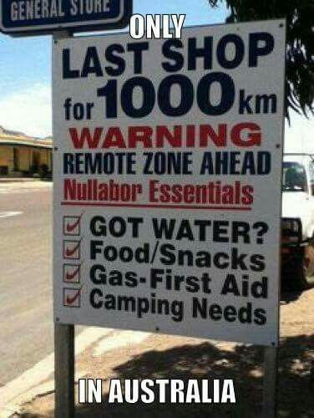
For those who like to shop, Australians are very keen on the 26th December Boxing Day Sales when there are some bargains at the shops. This time of year children are all on school holiday for 6 weeks to enjoy the summer break so there are a lot of outdoor activities and events organised in most towns.
The heat and the Australian flies might be a problem but it is wonderful time to enjoy the great landscape Australia offers – deserts, beaches, rainforests, and cities to explore. This is a time when families will make a trip to a particular area of Australia over the Christmas break to discover new parts of Australia – it’s a big country and road trips do take some time.

If you get a chance to experience an Australian Christmas – make sure you bring your swimming costume, a large hat, sunglasses, some sunblock and a good book to relax at the beach, the river or a lake (and maybe a little insect repellent).

Wishing you a Merry Christmas from Australia – its only 15,921 km to get here

zhromaždenie
mäso zo stehna ošípanej
krevety
losos
vaječný koňak
nezbedný, škodoradostný
Austrálčania (Australians) – Aussies (slang. Výraz)
chrumkavá zapečená cukrová pena
šľahačka
marakuja
krém na opaľovanie

