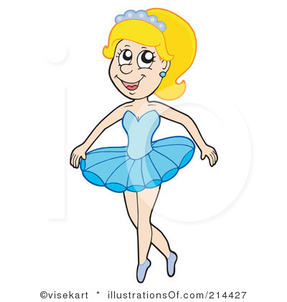

***I am Anna.***

***I am a ballerina.***

***I amnot a teacher.***

***I am seven. I amnot five.***

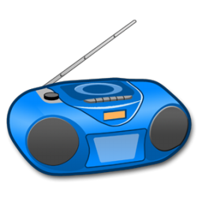

***It is a radio.***

***It is not a TV.***

***It is blue.***

***It is not black.***

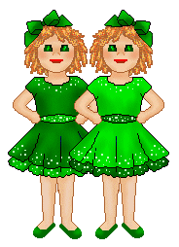

***They are twins.***

***They are sisters.***

***They arenot brothers.***

***They are Kate and Jane.***

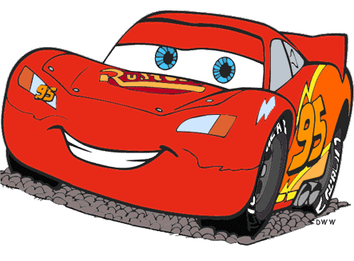

***It ____ a car.***

***It ____ _____ a plane.***

***It ____ red.***

***It ____ _____ black.***



***It ____ a cake.***

***It ____ _____ a lemon.***

***It ____ pink.***

***It ____ _____ blue.***

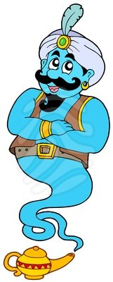

***He ____ a genie.***

***he____ ____ a boy.***

***He ____ blue.***

***He ____ _____ red.***

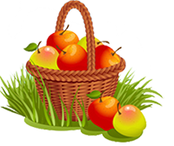

***They _____ apples.***

***They ____ _____ oranges.***

***They _____ red and yellow.***

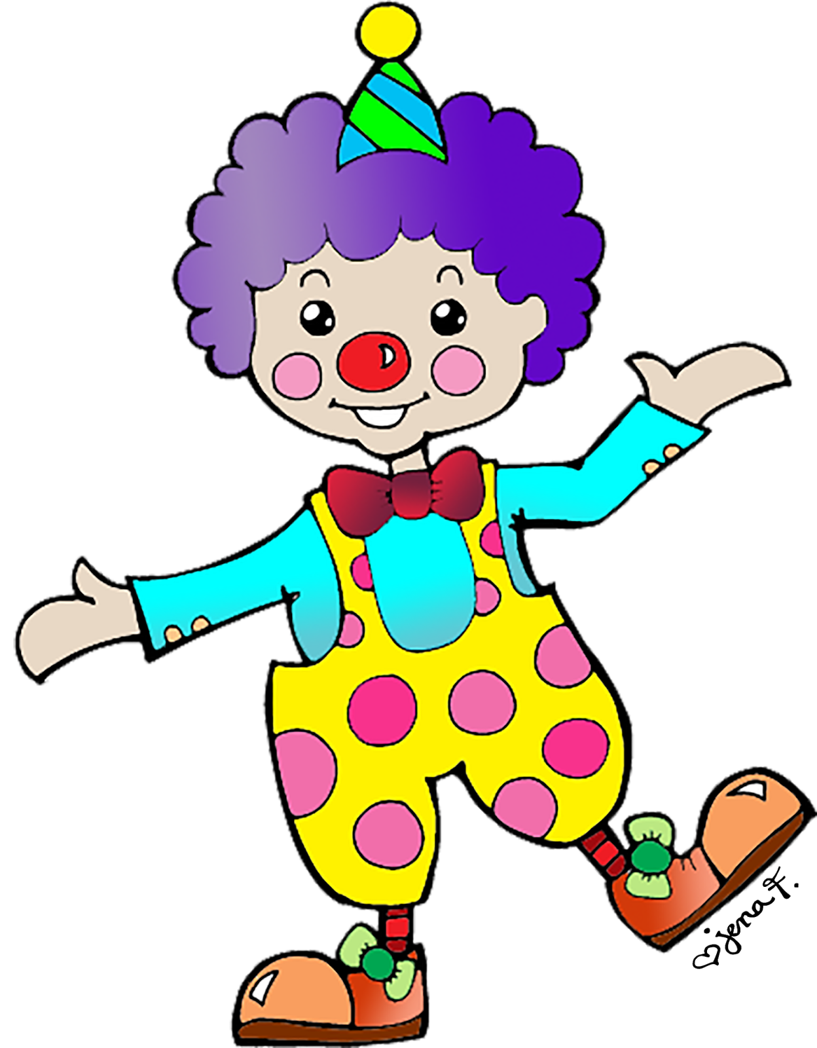

***He _____ Tom.***

***He _____ a clown.***

***He ____ _____ a genie.***

***He _____ ten.He ___________ eleven.***

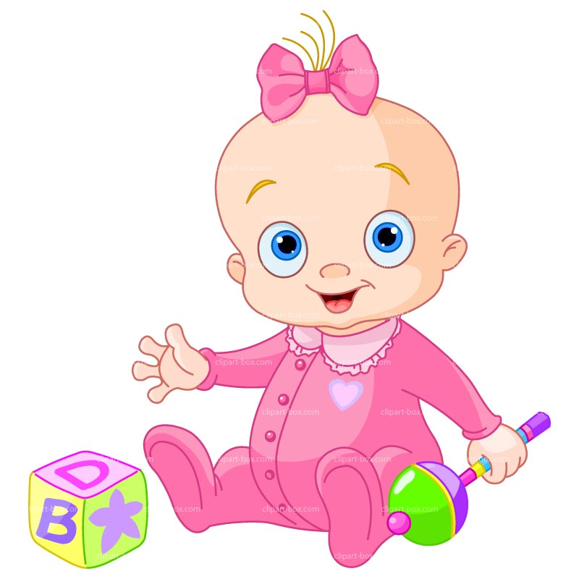

***She _____ Emma.***

***She _____ a baby.***

***She ____ _____ a doll.***

***She _____ one.***

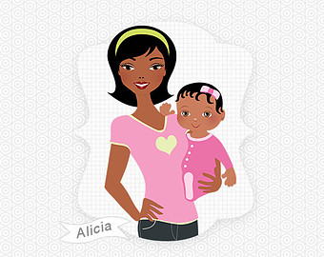

***She _____ Amelia.***

***She _____ a mother***

***She ____ _____ a father.***

***She _____ nice.***

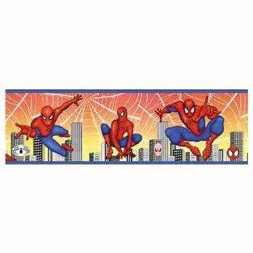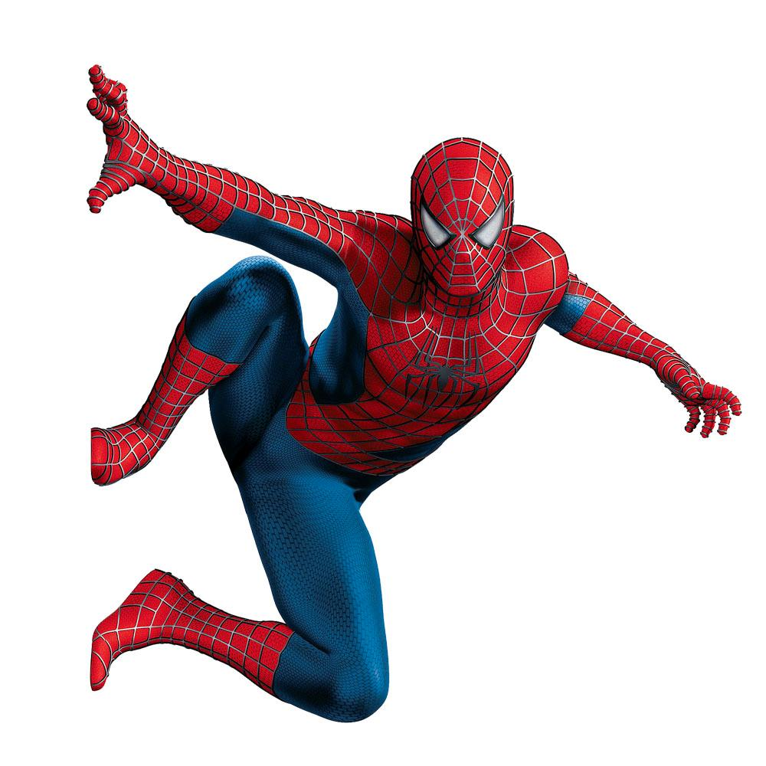

***Ishea Spiderman?***

***Yes, he is. He is a Spiderman.***

***Ishea doctor?***

***No, he is not. He is nota doctor.***

***She _____ one.***

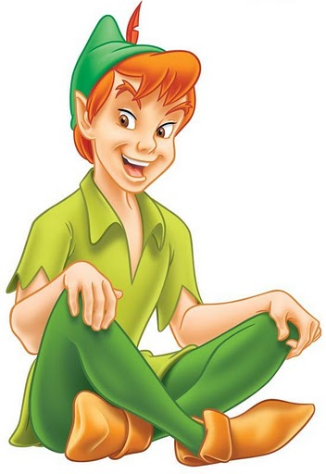

***IshePeter Pen?***

***Yes, _____ ____. _____ _____ __________.***

***Is_____Aladdin?***

***No, _____ _____ ______.He _____ notAladdin.***

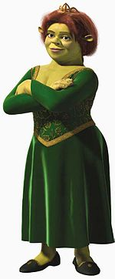

***IssheFiona?***

***Yes, _____ ____. _____ _____ __________.***

***Is_____Winx?***

***No, _____ _____ ______.She _____ notWinx.***

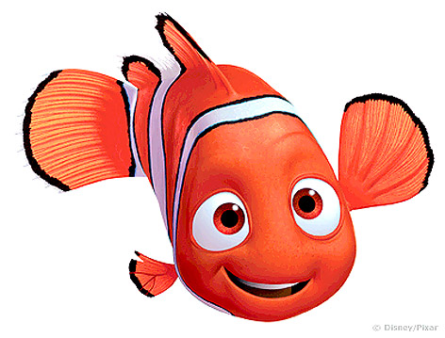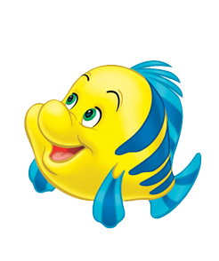

***AretheyNemo and Flounder?***

***Yes, _____ _____. They _____ __________ and Flounder.***

***_____theyShrek and Donald?***

***No, _____ _____ ______.They _____ not_______ and Donald.They are fish.***